Advanced Database Techniques
Prepared: TrangNTT
Lab 6-2. Advanced Database Techniques 1
6.1. Install PEAR DB 2
6.2. Authentication and SQL Injection 2
6.3. Modify the business listing service from previous class 3

Install PEAR DB
- Goes to http://pear.php.net/manual/en/installation.getting.php to get the installation guide of PEAR DB.
- Follow the guide to install PEAR DB to your Apache server and check if PEAR works.
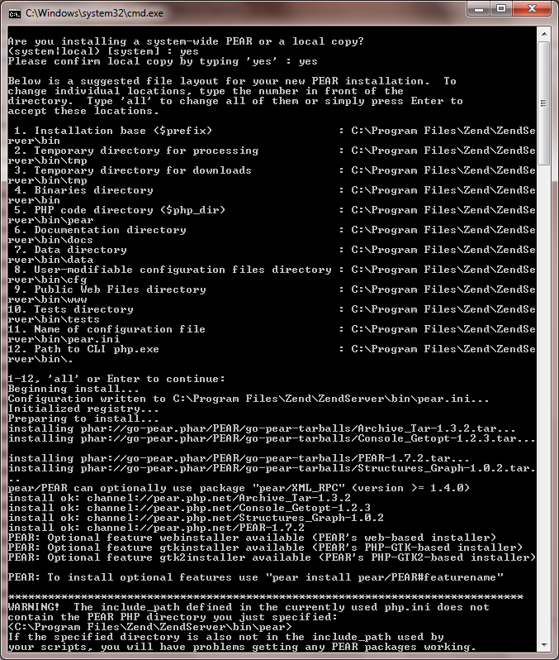

Authentication and SQL Injection
Get the login form in the exercise 9.4 of Lab 09 to do the followings:

Enter the following case for username or password and see what happens
- ' or 1=1; #
- ' UNION ALL SELECT * FROM users #
- '; DROP TABLE Users (Be careful with that input)
- '; INSERT INTO Users…

Modify Authentication to prevent SQL injection
Use the following techniques to ensure that the Login form will not be SQL Injection attacker (Ex.)
- Using mysql_real_escape_string()
- Using parameterized/prepared SQL of mysqli
- Using parameterized/prepared SQL of PEAR DB

Modify the business listing service from previous class
Modify the business listing service from previous class to ensure all the pages will not be attacked by SQL Injection.
- Using mysql_real_escape_string()
- Using parameterized/prepared SQL of mysqli
- Using parameterized/prepared SQL of PEAR DB
- Using parameterized/prepared SQL of PDO
The suggestion is for PEAR DB. This is only suggestion, there can be some errors or omited, you have to complete them. Good luck!

Create db_login.php includes all DB parameters
<?php
# parameters for connecting to the "business_service"
$username = "root"; $password = "12345";
$hostspec = "localhost"; $database = "business_service";
// $dbtype = 'pgsql';
// $dbtype = 'oci8';
$dbtype = 'mysqli';

# DSN constructed from parameters
$dsn = "$dbtype://$username:$password@$hostspec/$database";

# Establish the connection
$db = DB::connect($dsn);
if (DB::isError($db)) {
die ($db->getMessage());
}
?>

Create Category Administration page
This page that allows administrators to add categories to the listing service. The input fields for adding a new record appear after a dump of the current data. The administrator fills in the form and presses the Add Category button, and the page redisplays with the new record. If any of the three fields are not filled in, the page displays an error message.
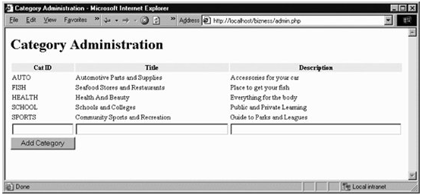
<html>
<head>
<?php
require_once('db_login.php');
?>

<title>
<?php
// print the window title and the topmost body heading
$doc_title = 'Category Administration';
echo "$doc_title\n";
?>
</title>
</head>
<body>
<h1>
<?php
echo "$doc_title\n";
?>
</h1>

<?php
// add category record input section

// extract values from $_REQUEST
$Cat_ID = $_REQUEST['Cat_ID'];
$Cat_Title = $_REQUEST['Cat_Title'];
$Cat_Desc = $_REQUEST['Cat_Desc'];
$add_record = $_REQUEST['add_record'];

// determine the length of each input field
$len_cat_id = strlen($_REQUEST['Cat_ID']);
$len_cat_tl = strlen($_REQUEST['Cat_Title']);
$len_cat_de = strlen($_REQUEST['Cat_Desc']);

// validate and insert if the form script has been
// called by the Add Category button
if ($add_record == 1) {
if (($len_cat_id > 0) and ($len_cat_tl > 0) and ($len_cat_de > 0)){
$sql = "insert into categories (category_id, title, description)";
$sql .= " values ('$Cat_ID', '$Cat_Title', '$Cat_Desc')";
$result = $db->query($sql);
$db->commit( );
} else {
echo "<p>Please make sure all fields are filled in ";
echo "and try again.</p>\n";
}
}

// list categories reporting section

// query all records in the table after any
// insertion that may have occurred above
$sql = "select * from categories";
$result = $db->query($sql);
?>

<form method="post" action="<?= $PHP_SELF ?>">

<table>
<tr><th bgcolor="#eeeeee">Cat ID</th>
<th bgcolor="#eeeeee">Title</th>
<th bgcolor="#eeeeee">Description</th>
</tr>

<?php
// display any records fetched from the database
// plus an input line for a new category
while ($row = $result->fetchRow( )){
echo "<tr><td>$row[0]</td><td>$row[1]</td><td>$row[2]</td></tr>\n";
}
?>
<tr><td><input type="text" name="Cat_ID" size="15" maxlength="10" /></td>
<td><input type="text" name="Cat_Title" size="40" maxlength="128" /></td>
<td><input type="text" name="Cat_Desc" size="45" maxlength="255" /></td>
</tr>
</table>
<input type="hidden" name="add_record" value="1" />
<input type="submit" name="submit" value="Add Category" />
</body>
</html>

Adding a Business
This page that lets a business insert data into the business and biz_categories tables.
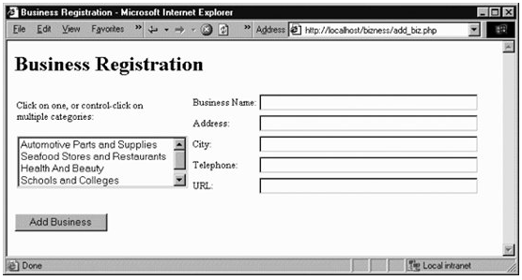
When the user enters data and clicks on the Add Business button, the script calls itself to display a confirmation page. The following figure shows a confirmation page for a company listing assigned to two categories.
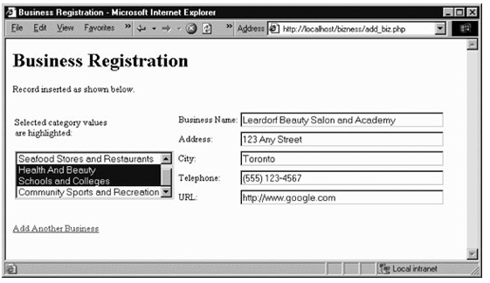
<html>
<head>
<title>
<?php
$doc_title = 'Business Registration';
echo "$doc_title\n";
?>
</title>
</head>
<body>
<h1>
<?= $doc_title ?>
</h1>

<?php
require_once('db_login.php');

// fetch query parameters
$add_record = $_REQUEST['add_record'];
$Biz_Name = $_REQUEST['Biz_Name'];
$Biz_Address = $_REQUEST['Biz_Address'];
$Biz_City = $_REQUEST['Biz_City'];
$Biz_Telephone = $_REQUEST['Biz_Telephone'];
$Biz_URL = $_REQUEST['Biz_URL'];
$Biz_Categories = $_REQUEST['Biz_Categories'];

$pick_message = 'Click on one, or control-click on<BR>multiple ';
$pick_message .= 'categories:';

// add new business
if ($add_record == 1) {
$pick_message = 'Selected category values<br />are highlighted:';
$sql = 'INSERT INTO businesses (name, address, city, telephone, ';
$sql .= ' url) VALUES (?, ?, ?, ?, ?)';
$params = array($Biz_Name, $Biz_Address, $Biz_City, $Biz_Telephone, $Biz_URL);
$query = $db->prepare($sql);
if (DB::isError($query)) die($query->getMessage( ));
$resp = $db->execute($query, $params);
if (DB::isError($resp)) die($resp->getMessage( ));
$resp = $db->commit( );
if (DB::isError($resp)) die($resp->getMessage( ));
echo '<p class="message">Record inserted as shown below.</p>';
$biz_id = $db->getOne('SELECT max(business_id) FROM businesses');
}
?>

<form method="post" action="<?= $PHP_SELF ?>">
<table>
<tr><td class="picklist"><?= $pick_message ?>
<p>
<select name="Biz_Categories[]" size="4" multiple>
<?php
// build the scrolling pick list for the categories
$sql = "SELECT * FROM categories";
$result = $db->query($sql);
if (DB::isError($result)) die($result->getMessage( ));
while ($row = $result->fetchRow( )){
if (DB::isError($row)) die($row->getMessage( ));
if ($add_record == 1){
$selected = false;
// if this category was selected, add a new biz_categories row
if (in_array($row[1], $Biz_Categories)) {
$sql = 'INSERT INTO biz_categories';
$sql .= ' (business_id, category_id)';
$sql .= ' VALUES (?, ?)';
$params = array($biz_id, $row[0]);
$query = $db->prepare($sql);
if (DB::isError($query)) die($query->getMessage( ));
$resp = $db->execute($query, $params);
if (DB::isError($resp)) die($resp->getMessage( ));
$resp = $db->commit( );
if (DB::isError($resp)) die($resp->getMessage( ));
echo "<option selected=\"selected\">$row[1]</option>\n";
$selected = true;
}
if ($selected == false) {
echo "<option>$row[1]</option>\n";
}
} else {
echo "<option>$row[1]</option>\n";
}
}
?>

</select>
</td>
<td class="picklist">
<table>
<tr><td class="FormLabel">Business Name:</td>
<td><input type="text" name="Biz_Name" size="40" maxlength="255"
value="<?= $Biz_Name ?>" /></td>
</tr>
<tr><td class="FormLabel">Address:</td>
<td><input type="text" name="Biz_Address" size="40" maxlength="255"
value="<?= $Biz_Address ?>" /></td>
</tr>
<tr><td class="FormLabel">City:</td>
<td><input type="text" name="Biz_City" size="40" maxlength="128"
value="<?= $Biz_City ?>" /></td>
</tr>
<tr><td class="FormLabel">Telephone:</td>
<td><input type="text" name="Biz_Telephone" size="40" maxlength="64"
value="<?= $Biz_Telephone ?>" /></td>
</tr>
<tr><td class="FormLabel">URL:</TD>
<td><input type="text" name="Biz_URL" size="40" maxlength="255"
value="<?= $Biz_URL ?>" /></td>
</tr>
</table>
</td>
</tr>
</table>
<p>
<input type="hidden" name="add_record" value="1" />

<?php
// display the submit button on new forms; link to a fresh registration
// page on confirmations
if ($add_record == 1){
echo '<p><a href="'.$PHP_SELF.'">Add Another Business</a></p>';
} else {
echo '<input type="submit" name="submit" value="Add Business" />';
}
?>

</p>
</body>
</html>

Business listing page
The page that displays the information in the database. The links on the left side of the page are created from the categories table and link back to the script, adding a category ID. The category ID forms the basis for a query on the businesses table and the biz_categories table.
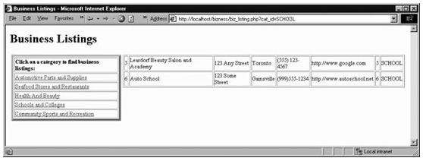
<html>
<head>
<title>
<?php
$doc_title = 'Business Listings';
echo "$doc_title\n";
?>
</title>
</head>
<body>
<h1>
<?= $doc_title ?>
</h1>

<?php
// establish the database connection

require_once('db_login.php');

$pick_message = 'Click on a category to find business listings:';
?>

<table border=0>
<tr><td valign="top">
<table border=5>
<tr><td class="picklist"><strong><?= $pick_message ?></strong></td></tr>
<p>
<?php
// build the scrolling pick list for the categories
$sql = "SELECT * FROM categories";
$result = $db->query($sql);
if (DB::isError($result)) die($result->getMessage( ));
while ($row = $result->fetchRow( )){
if (DB::isError($row)) die($row->getMessage( ));
echo '<tr><td class="formlabel">';
echo "<a href=\"$PHP_SELF?cat_id=$row[0]\">";
echo "$row[1]</a></td></tr>\n";
}
?>
</table>
</td>
<td valign="top">
<table border=1>
<?php
if ($cat_id) {
$sql = "SELECT * FROM businesses b, biz_categories bc where";
$sql .= " category_id = '$cat_id'";
$sql .= " and b.business_id = bc.business_id";
$result = $db->query($sql);
if (DB::isError($result)) die($result->getMessage( ));
while ($row = $result->fetchRow( )){
if (DB::isError($row)) die($row->getMessage( ));
if ($color == 1) {
$bg_shade = 'dark';
$color = 0;
} else {
$bg_shade = 'light';
$color = 1;
}
echo "<tr>\n";
for($i = 0; $i < count($row); $i++) {
echo "<td class=\"$bg_shade\">$row[$i]</td>\n";
}
echo "</tr>\n";
}
}
?>
</table>
</td></tr>
</table>
</body>
</html>

